Experiment Name:
Software Configuration Management with Git and GitHub

Objective:
- To understand the fundamental concepts and importance of Software Configuration Management (SCM) and version control.
- To learn and practice basic, essential Git commands for local version control.
- To gain experience with remote repositories by using GitHub
- To implement and understand the "branch and merge" workflow by creating feature branches

Theory:
Git is a distributed version control system widely used in modern software development. It enables developers to track code changes, restore previous versions, and collaborate efficiently with others.
GitHub is an online platform that hosts Git repositories and offers collaboration tools such as pull requests and issue tracking. In this experiment, I will explore the fundamental Git workflow by creating a local repository, making commits, and pushing your work to a remote GitHub repository.

Required Equipment / Software
- A computer with an internet connection.
- Git installed on your system.
- A free GitHub account.
- A text editor or IDE

Procedure Followed:
- Install Git
- Configure Git:
git config --global user.name "Md. Asad-Al-Adil"
git config --global user.email "adilasadals@gmail.com.com"

- Create a Project: A HTML Portfolio website is created along with index.html
- Create GitHub Repository: A repository is created named asadaladil.github.io
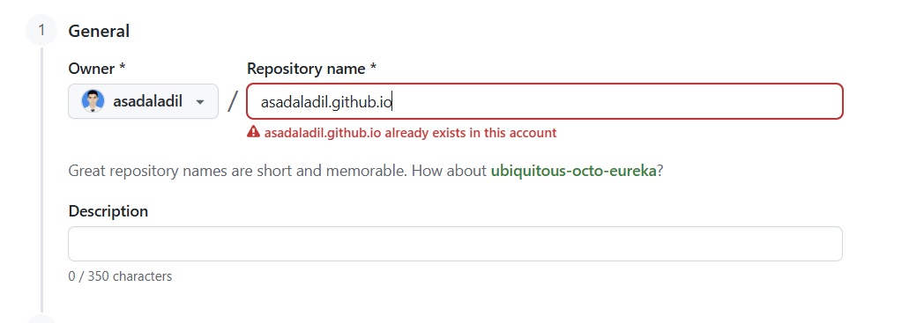

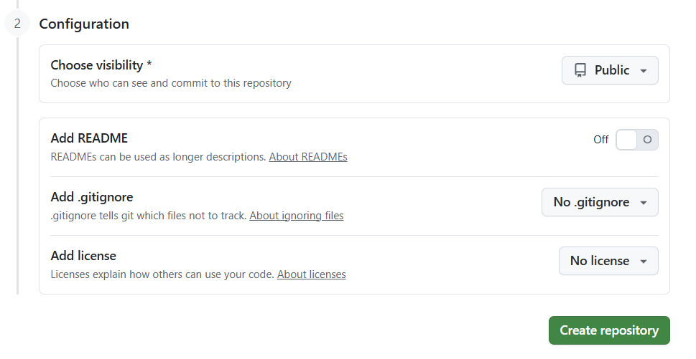

- Push to GitHub:
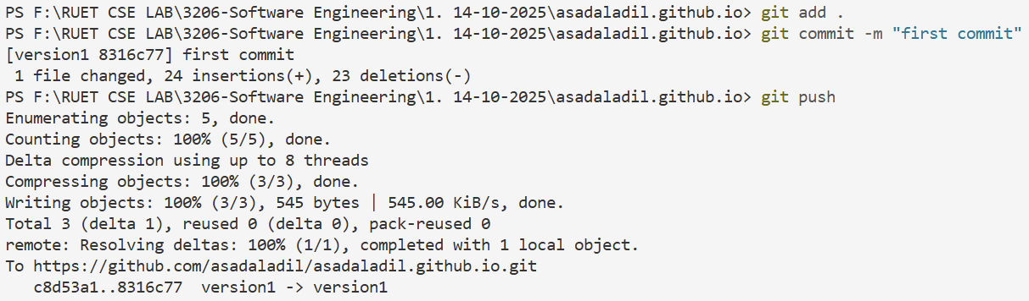
8. Verify: Refresh your GitHub repository page.
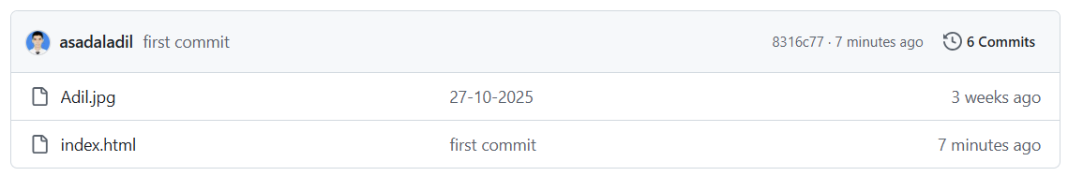

Branching and Merging
1. Setup:
git init
git add .
git commit -m "Initial commit"

2. Create a Feature Branch: Create a new branch named version1.
git branch version1
git checkout version1

3. Implement the Feature: In the version1 branch modifies the index.html and commit the changes.
# ... after modifying the file ...
git add index.html
git commit -m "Updated Portfolio website"

4. Merge the Feature: Switch back to the main branch and merge the feature branch into it.
git checkout main
git merge version1

Forking and Pull Request
- Fork a Repository: Find a public repository on GitHub and click the "Fork" button. This creates a personal copy of the repository under your account.

- Clone the Fork: Clone your forked repository to your local machine.
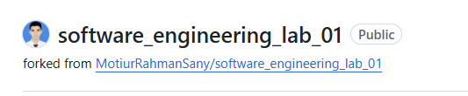
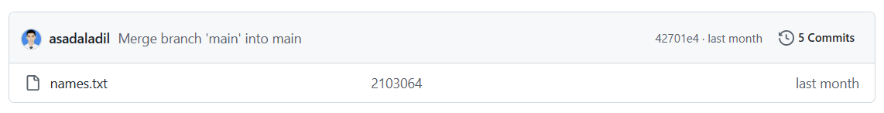
- Push to Your Fork: Push the new branch to your forked repository on GitHub.
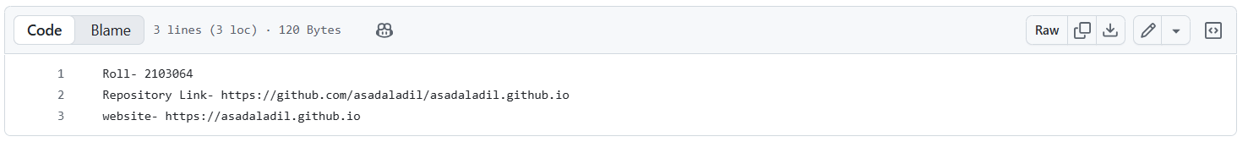
- Create a Pull Request (PR): Go to your forked repository on GitHub. You will see a prompt to create a pull request. Click it, add a title and description for your changes, and submit the PR. This asks the original repository's owner to "pull" your changes into their project.
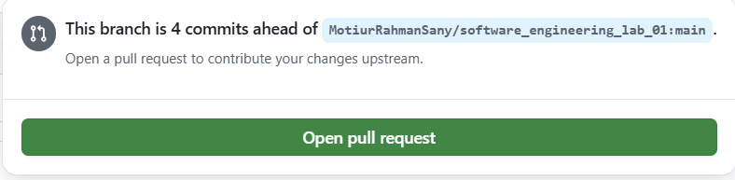
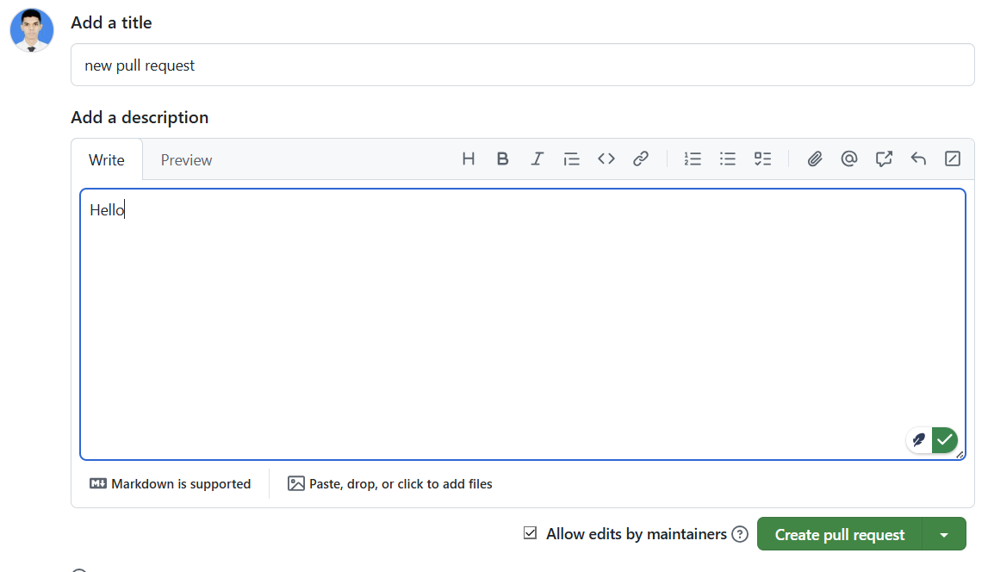
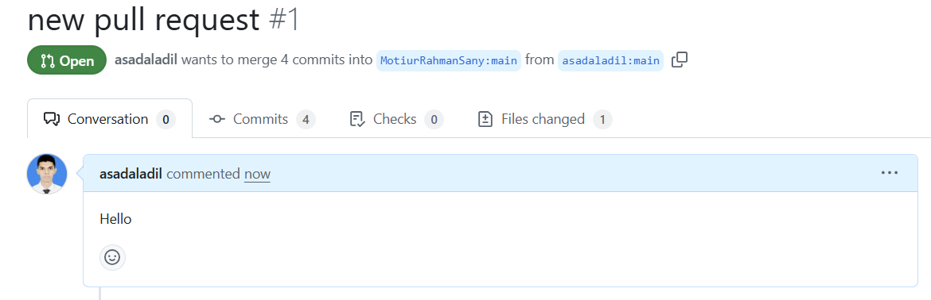

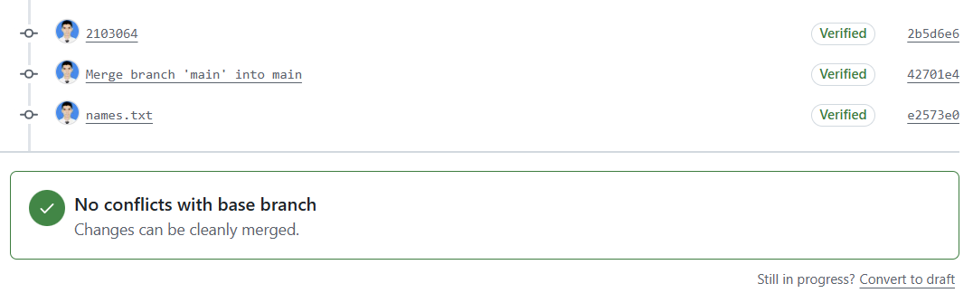
Github Server:
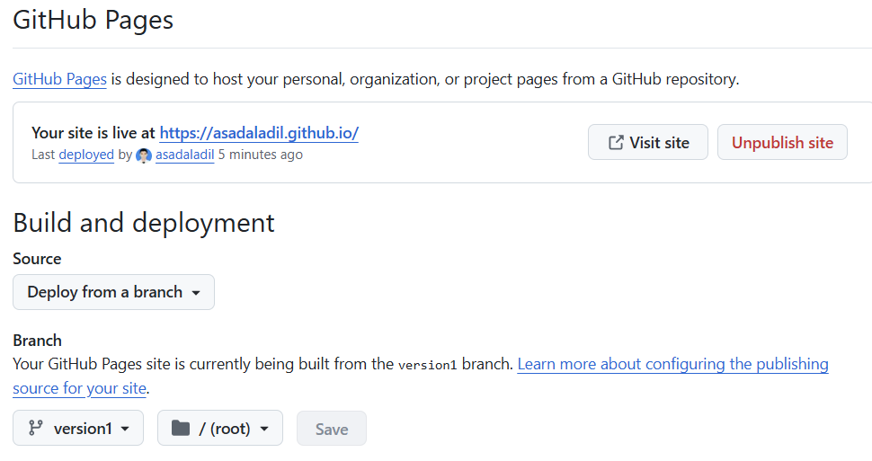
----After Hosting the server---


Conclusion:
GitHub is the backbone of modern development. It bridges the gap between code management and team collaboration, ensuring that software is built faster, safer, and more transparently.

